CS-002 Layup Schedule Specification & Recording
Doc ID | CS-002
Title | Layup Schedule Specification & Recording
Revision | E
Status | Draft, pending Lead signature
Effective date | 2026-08-29
Supersedes | Master Tracker "Layup Schedule" shorthand as the only stack record

Approvals
Role | Name | Date
Author | Simon Starbuck (drafted with Claude, SN6 Resources) | 2026-07-12
Reviewer | simon (reviewer agent)
Approver (Composites Lead)

Revision history
Rev | Date | Author | Description of change
A | 2026-07-12 | Claude | Initial issue
B | 2026-07-28 | Claude | Language pass: fewer em dashes for rhythm variety, no content change.
C | 2026-08-03 | Claude | §7 gains the coupon suffix convention and the rule that coupon IDs are written on the panel before the first cut (CS-001 §7.6, CS-013 §4.1).
D | 2026-08-28 | Claude | Engineering pass (CS-000 Rev C conventions). Figure 1 draws the §7.3 example stack in section, so "P1 is the mold side" stops being a convention people have to hold in their heads at the cutting table. No rule changed.
E | 2026-08-29 | Claude | Coupons caught up with the app's v4.0.0 R&D bench (CS-013 Rev F): a coupon is CPN-SNx-### under a study that carries the stack and lots, so the filename-to-layup chain now runs through the study record. The write-the-ID-before-the-first-cut rule is unchanged.

1. Purpose
In SN5 our stacks lived in the tracker as shorthand ("6X 195 + CORE", "195 88 .25 NOMEX"). That's the intent, not what actually got laid. Orientations, core placement, where the copper mesh went, what we substituted when we ran out of cloth: all of it lived in people's heads. That's how the dashboard got remade 3+ times against a spec that existed nowhere (PP-04), how the UT stack was still up in the air three weeks before layup (PP-07), and why nobody could answer "what stack did the seat use last year?" (PP-09). This doc is how we write a stack down before we build, and record what we actually did after.

2. Scope
Every laminated part: infusion, wet layup, foam-wrapped, and forged CF (mass/ratio spec instead of ply table). Applies to R&D coupons too, since untraceable test data is noise.

3. References
Ref | Document | Where
R1 | PP-04, PP-07, PP-09 RCAs | FEB-COMP-PP-001
R2 | CS-013 Work Orders (where stacks are recorded) | CS-013
R3 | Rohacell IG-F TDS (core naming example) | 03 Datasheets/ROHACELL_IG_F_2022_April_EN_243534.pdf
R4 | Materials Testing & Recommendation (SN5 coupon data) | SN5 Composites/Documentation/Materials Testing & Recommendation.docx

4. Definitions
- Stack / layup schedule: the full ordered list of plies from mold surface (P1) outward, including cores, meshes, and inserts.
- Orientation: warp direction relative to the part's marked 0° datum. For woven cloth use 0/90 or ±45; for spread-tow/UD state the fiber direction.
- Cloth naming: <gsm> <weave> from the team's stock: 88 spread-tow, 195 twill, 220 twill, 670 twill (Sigmatex); always gsm, never "the thick one".
- Stack freeze: the signed decision that the stack will not change without a WO revision.

5. Equipment & Materials
None; this is a specification standard. The stack table lives in the part's work order (R2).

6. Safety
No physical hazards; specification standard. Shop-floor safety lives in the process standards it feeds (CS-006, CS-007).

7. Procedure

7.1 Specify (before any manufacturing)
- The part's Manufacturing Engineer drafts the stack as a ply table (format in 7.3), from mold surface outward.
- Justify the choice in one or two lines per decision: coupon data (R4), the SN5 as-built for a similar part (its WO), or an explicit assumption flagged for testing. New unproven stacks on schedule-critical parts require a coupon or test panel first.
- Include function plies explicitly: sacrificial 88 spread-tow outer layers for sanding protection, copper mesh position and overlap for grounded parts (CS-010), core chamfers/grooves.
- State the target: cured thickness (mm), mass (g), and any acceptance measurement (e.g. grounding Ω per CS-010).

7.2 Freeze
- The stack freezes before mold machining starts. Mold geometry (offsets, flange height) can depend on stack thickness, and machine slots are too scarce to cut twice (PP-03, PP-06). For mold-less flat panels, freeze before cloth is cut.
- Freeze = ME/RE and the Composites Lead (plus the requesting subteam's lead for cross-team parts, the dashboard lesson, PP-04) initial the WO's stack table.
- Every stack-freeze date appears as a deadline in the season timeline, reviewed at the Monday meeting (PP-07). A frozen-stack change requires a WO revision: quick to do, but visible and counted.

7.3 Ply table format
Ply | Material | Orientation | Coverage | Notes
P1 (mold side) | 88 spread-tow | 0/90 | full | sacrificial/finish
P2 | 195 twill | ±45 | full
P3 | Cu mesh | n/a | zones A–B | grounding, 25 mm overlap onto P2
P4 | Rohacell 31 IG-F 3 mm | n/a | core zone | chamfer 20°, grooves per CS-006
P5–P6 | 195 twill | 0/90, ±45 | full
P7 (bag side) | 88 spread-tow | 0/90 | full

(Example only: the table above is the format, not a recommended stack.)
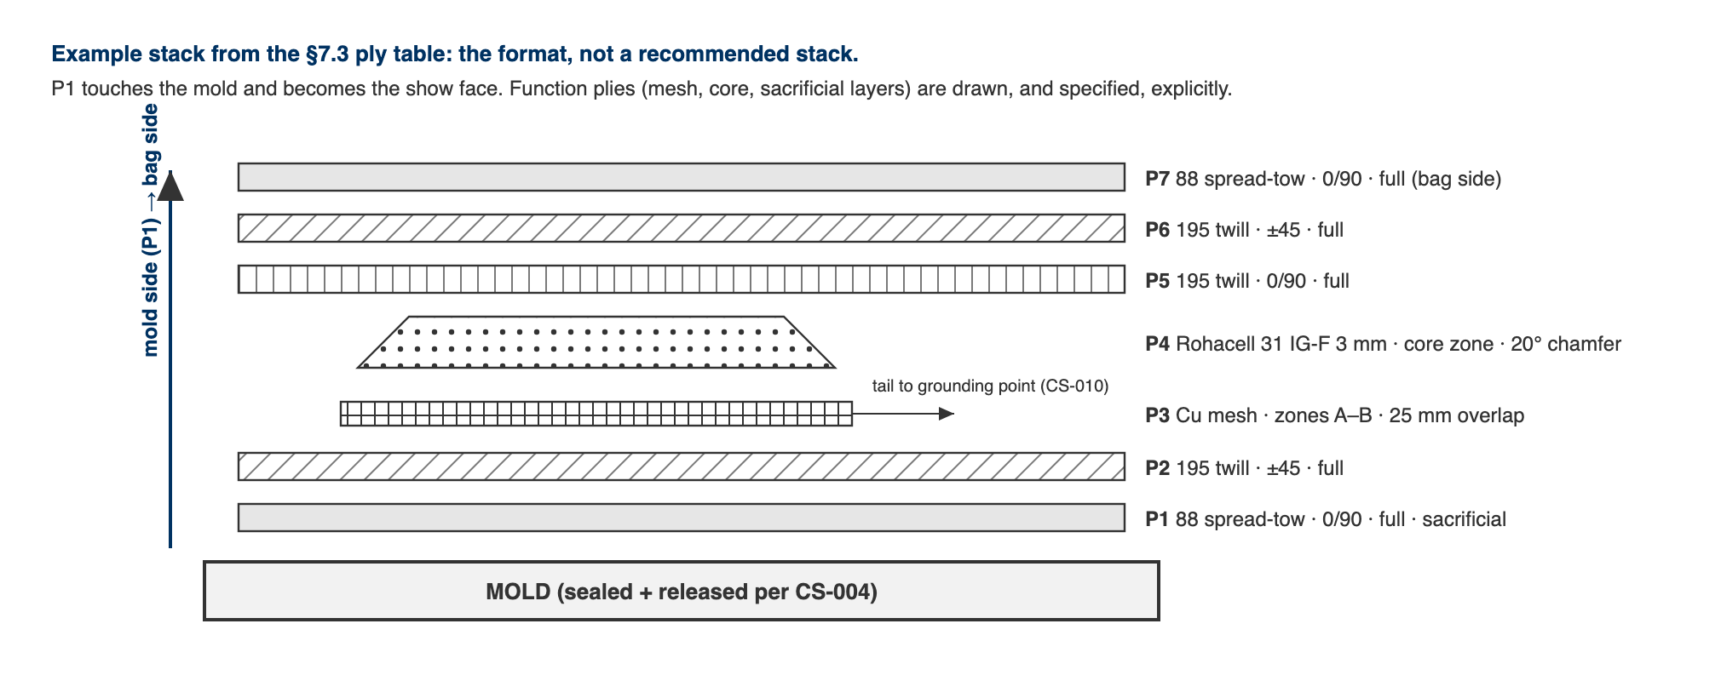
Figure 1. The §7.3 example stack drawn in section. P1 touches the mold and becomes the show face; function plies are drawn, and specified, explicitly.

7.4 Record as-built (during/after layup)
- During layup, the RE ticks each ply as laid and notes any deviation in the WO (substituted cloth, extra ply, mesh moved). No deviation is too small to note: "we were out of 195 so used 220" is exactly the data that explains a mass or thickness surprise later.
- Photograph the stack at: cores/mesh placed, and bagged-before-infusion. Photos attach to the WO steps.
- After cure, record actual mass and thickness next to targets in the WO qualityChecks.

Coupons
A coupon is CPN-SNx-###: its own record on the app's R&D bench, belonging to a study RDS-SNx-### (CS-013 §4.1). The study carries the stack, fabric lots, resin and hardener lots once, and every coupon inherits them unless a coupon overrides its own; that inheritance is what makes one coupon ID enough to recover the whole build. (The retired suffix spelling PNL-SNx-###-Cnn survives only on frozen SN5-era records.)
- Write every coupon ID on the panel before the first cut, across the cut lines, so each piece inherits a legible fragment. After the saw there is no way to recover which piece was which.
- Name the raw data file after the coupon: CPN-SN6-042.csv. That one filename then carries the study, the stack, the session and the material lots, through one link each, none of them retyped.
⚠ CAUTION: This is written against a real failure. The SN5 tensile set is seventeen CSVs named TensileTesting_12_8_2025_<n>.csv whose contents are Time, Displacement and Force with no header block and no specimen identity of any kind. The mapping from specimen to layup exists only in a Word table that contradicts itself. Untraceable test data is noise (§2).

8. Quality checks / acceptance criteria
Check | Target | Method | Record where
Stack frozen before mold machining / cloth cut | Initials + date present | WO blocker step | WO
As-built matches frozen stack | Any deviation noted, none silent | RE self-check + photo review | WO
Mass vs target | Within stated tolerance (default ±10%) | Scale | WO qualityChecks
Thickness vs target | Within stated tolerance | Calipers at 3+ points | WO qualityChecks

9. Records
The WO ply table (spec + as-built + deviations + photos) is the permanent record. The Master-Tracker-style shorthand may still be used in dashboards/summaries, but it is a view of the WO, never the source of truth.

